Learn from the task

Web scraping

<https://realpython.com/beautiful-soup-web-scraper-python/>

**Topic Modeling in Python: Latent Dirichlet Allocation (LDA)**

<https://towardsdatascience.com/end-to-end-topic-modeling-in-python-latent-dirichlet-allocation-lda-35ce4ed6b3e0>

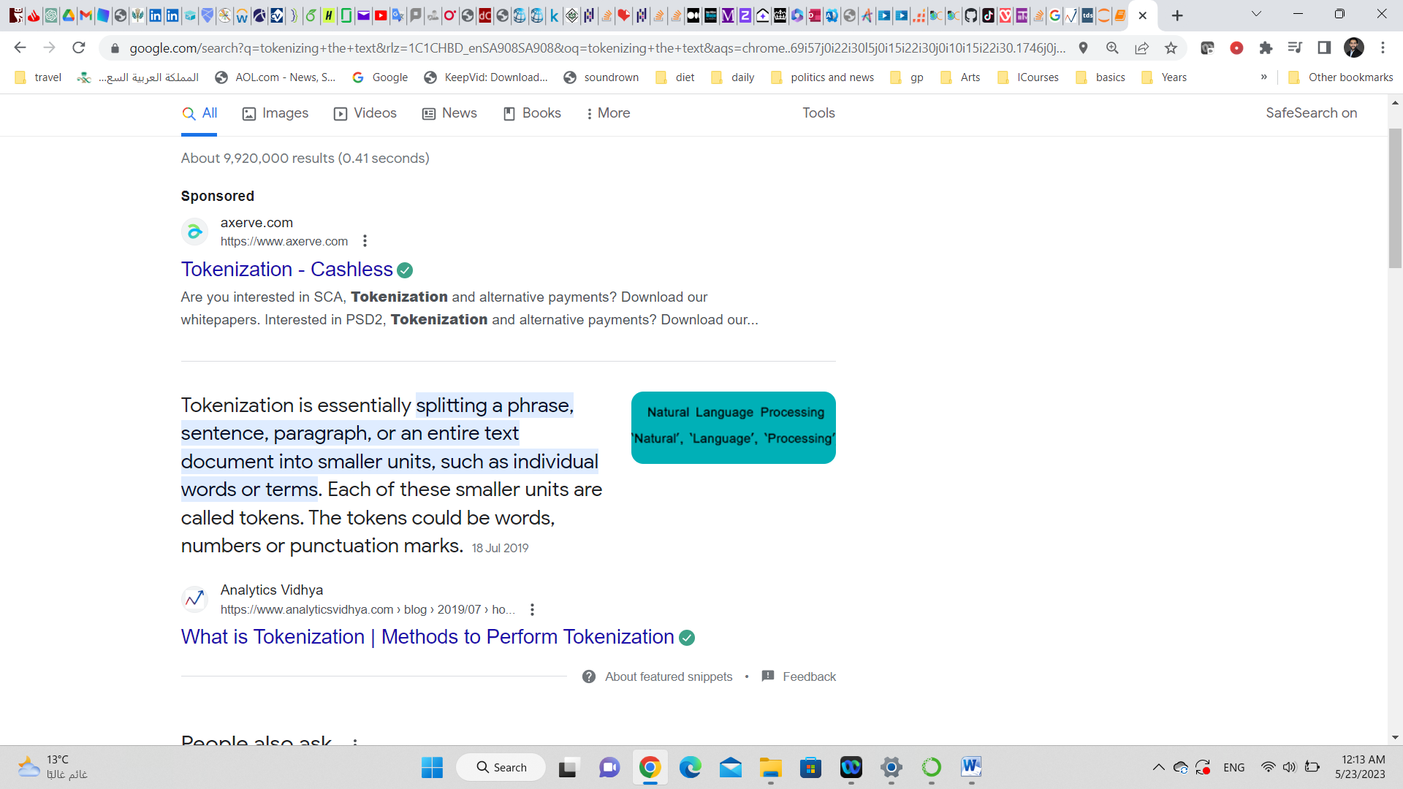

# Sentiment Analysis Using Python

<https://www.analyticsvidhya.com/blog/2022/07/sentiment-analysis-using-python/>

# Sentiment Analysis using TextBlob

<https://towardsdatascience.com/my-absolute-go-to-for-sentiment-analysis-textblob-3ac3a11d524>

<https://stackoverflow.com/questions/46764674/sentiment-analysis-on-dataframe>

Important for data cleaning for text:

# Text Cleaning for NLP: A Tutorial

<https://monkeylearn.com/blog/text-cleaning/>

**models**

<https://scikit-learn.org/stable/supervised_learning.html>

random forest

<https://towardsdatascience.com/understanding-random-forest-58381e0602d2>

Random Forest Classification with Scikit-Learn

<https://www.datacamp.com/tutorial/random-forests-classifier-python>